**mHealh Database**

Corey Bright

Elijah Chong Tay

Hannah Applebaum

Harpreet Bains

Faizan Rafieuddin

Adesh Rai

Group 2

**Table of Contents**

Introduction 2

Introduction 2

Project Specification 2

Statement of Objectives 2

Requirements 2

Design 3

*Schema* 3

*Data Dictionary* 4

*Constraints* 6

*Queries* 8

*Requirements Matrix* 8

*Entity-Relationship Diagram* 9

Test Plan 9

**Introduction**

This document attempts to summarize the requirements, analysis, and design of a database system designed to support the needs of Hazen health center workers and patients.

**Project Specification**

This database will contain information related to patients i.e., college students and teachers. It will have tables that store appointment times and dates. It will also have tables that have all the patient information relating to medicines, allergies, personal information, disabilities, emergency contacts, vaccinations, etc. This database will also have a table that stores all relevant information for the Doctors present at the Hazen Health Center for e.g., their availability, specialization etc. Additionally, it will allow for communication via messages between the employees of the Hazen Health Center and the patients.

**Statement of Objectives**

The Database system we will be working on is related to the Hazen Health Portal. It would facilitate the operational team at Hazen to store health-related information allowing more functionality to the simple frontend that has already been designed. This database will allow for better health care by improving all aspects of patient care, including effectiveness, patient-centeredness, communication, efficiency, and equity.

**Requirements**

The requirements list is as follows:

1. The database must have functionalities that enable a patient to schedule appointments with no overlaps at the same time between different patients and the same patient.
2. The database must allow patients to cancel and reschedule appointments based on the situation.
3. The database must provide functionalities that enable the staff at the Hazen Health Center to retrieve and inspect information regarding the patients, appointments, when required and according to their respective roles.
4. The database must contain the information related to doctors currently working at the Hazen Health center along with their specialization and availability throughout the day.
5. The database must contain immunization, insurance, and medication information for the patients.
6. The database must allow multiple medications, immunizations, and insurances for a patient as there is a possibility that these fields have multiple entries.
7. The database must allow two-way communication between the patients and the employees of the Hazen Health Center via messaging.

**Design**

***Schema***

**person** (person_id: INT, first_name: STRING, middle_intial: STRING, last_name: STRING, date_of_birth: DATE, address: STRING) Keys: {person_id}, {first_name, last_name, date_of_birth, address}

**email** (person_id: INT references person, email: STRING) Keys: {person_id, email}

**phone_number** (person_id: INT references person, phone_number: INT) Keys: {person_id, phone_number}

**patient** (patient_id: INT reference person(person_id), minor: BOOLEAN) Keys: {patient_id}

**doctor** (doctor_id: INT reference person(person_id) Keys: {doctor_id}

**specialty** (doctor_id: INT references doctor, specialty: STRING) Keys: {doctor_id, specialty}

**availability** (doctor_id: INT references doctor, availability: STRING) Keys: {doctor_id, specialty}

**employee** (employee_id: INT reference person(person_id), job_title: STRING, start_date: DATE, end_date: DATE) Keys: {employee_id}

**appointment** (appointment_id: INT, location: STRING, date: DATE, time: TIME, patient_id: INT references patient, doctor_id: INT references doctor) Keys: {appointment_id}, {location, date, time}

**insurance** (insurance_id: INT, patient_id: INT references patient, group_number: INT, name: STRING, Phone#: TELNUM, Address: STRING) Keys: {insurance_id}

**medication** (medication:_id, INT, patient_id: INT references patient,  name: STRING, start_date: DATE, end_date: DATE) Keys: {medication_id)

**immunization** (immunization_id: ID, patient_id: INT references patient, name: STRING, date: DATE) Keys: {immunization_id}

**message** (message_id: INT,  sender_id: INT references employee(employee_id), receiver_id: INT references patient(patient_id), body: STRING, date: DATE, time: TIME) Keys: {message_id}

***Data Dictionary***

PERSON

|  |  |  |  |
| --- | --- | --- | --- |
| Attribute | Data Type | Defines | Example |
| person_id | INT | Key for a person | 1 |
| first_name | VARCHAR(20) | Person’s first name | Henry |
| middle_initial | VARCHAR(1) | Person’s middle initial (optional, defaults to blank) | W |
| last_name | VARCHAR(30) | Person’s last name | Ale |
| date_of_birh | DATE | Person’s birth day (Format: YYYY-MM-DD) | 2001-11-09 |

TELEPHONE

|  |  |  |  |
| --- | --- | --- | --- |
| Attribute | Data Type | Defines | Example |
| telephone | INT(10) | Person’s 10 digit telephone number | 5854385531 |
| person_id | INT | Key for a person | 1 |

EMAIL

|  |  |  |  |
| --- | --- | --- | --- |
| Attribute | Data Type | Defines | Example |
| email | VARCHAR(100) | Person’s email address | [abc123@brcokport.edu](mailto:abc123@brcokport.edu) |
| person_id | INT | Key for a person | 1 |

EMPLOYEE

|  |  |  |  |
| --- | --- | --- | --- |
| Attribute | Data Type | Defines | Example |
| employee_id | INT | Key for an employee | 12 |
| start_date | DATE | Date employee started (Format: YYYY-MM-DD) | 2015-02-03 |
| end_date | DATE | Date employee ended  (Format: YYYY-MM-DD)  (optional, defaults to blank) | 2016-03-24 |
| job_title | VARCHAR(30) | Employee’s job position | Secretary |

PATIENT

|  |  |  |  |
| --- | --- | --- | --- |
| Attribute | Data Type | Defines | Example |
| patient_id | INT | Key for a patient | 9 |
| minor | BOOLEAN | Sees if patient is a minor or not | True |

MESSAGE

|  |  |  |  |
| --- | --- | --- | --- |
| Attribute | Data Type | Defines | Example |
| message_id | INT | Key for message | 57 |
| sender_id | INT | Key for sender | 1 |
| receiver_id | INT | Key for receiver | 8 |
| title | VARCHAR(50) | Title of message | Reminder |
| body | TEXT | Message being sent | This is your reminder that you have an appointment on 02/14/2024 |

INSURANCE

|  |  |  |  |
| --- | --- | --- | --- |
| Attribute | Data Type | Defines | Example |
| insurance_id | INT | Key for insurance | 25 |
| patient_id | INT | Key for a patient | 1 |
| name | VARCHAR(80) | Insurance Name | Blue Cross Blue Shield Association |
| policy_number | CHAR(20) | Insurance policy number | BC331FFS31S2D |
| group_number | CHAR(20) | Insurance group number | 234BX3FGH12 |

IMMUNIZATION

|  |  |  |  |
| --- | --- | --- | --- |
| Attribute | Data Type | Defines | Example |
| immunization_id | INT | Key for immunization | 8 |
| patient_id | INT | Key for a patient | 1 |
| name | VARCHAR(50) | Name of vaccine | Chickenpox Vaccination |
| date | DATE | Date vaccine was given  (Format: YYYY-MM-DD) | 2015-08-13 |

MEDICATION

|  |  |  |  |
| --- | --- | --- | --- |
| Attribute | Data Type | Defines | Example |
| medication_id | INT | Key for medication | 30 |
| patient_id | INT | Key for a patient | 1 |
| start_date | DATE | Date medication started  (Format: m-d-yyyy) | 2013-10-09 |
| end_date | DATE | Date medication ended  (Format: YYYY-MM-DD)  (optional, defaults to blank) | 2013-11-09 |

DOCTOR

|  |  |  |  |
| --- | --- | --- | --- |
| Attribute | Data Type | Defines | Example |
| doctor_id | INT | Key for doctor | 5 |

SPECIALTY

|  |  |  |  |
| --- | --- | --- | --- |
| Attribute | Data Type | Defines | Example |
| doctor_id | INT | Key for doctor | 5 |
| specialty | VARCHAR(30) | Describes what the doctor specializes | Neurology |

AVAILABILITY

|  |  |  |  |
| --- | --- | --- | --- |
| Attribute | Data Type | Defines | Example |
| doctor_id | INT | Key for a doctor | 1 |
| available | VARCHAR(35) | Day and time that doctor is available  (format: “DAY HH:MM AM/PM – HH:MM AM/PM”) | Wednesday 9:00AM – 4:00PM\\\\\\ |

APPOINTMENT

|  |  |  |  |
| --- | --- | --- | --- |
| Attribute | Data Type | Defines | Example |
| appointment_id | INT | Key for appointment | 30 |
| patient_id | INT | Key for a patient | 1 |
| doctor_id | INT | Key for a doctor | 8 |
| start_time | DATETIME | Date and time for start of appointment  (Format: YYYY-MM-DD HH:MI:SS) | 2023-02-14 12:30:00 |
| endtart_time | DATETIME | Date and time for end of appointment  (Format: YYYY-MM-DD HH:MI:SS) | 2023-02-14 13:00:00 |

***Constraints***

**The following custom domains are part of the solution:**

**location:** This attribute defines the location where the appointment would take place, this can be either one of the two options i.e., “Online” or “In Person”.

**time:** This attribute defines the time when the appointment will take place. The domain of times from which a value can be chosen for this attribute must be in between 8:00 AM to 6:00 PM.

**start date:** This attribute defines the start date of a medicine and it should be between the dates from January 1950 to December 2100 (just in case).

**end date:** This attribute defines the end date of a medicine and it should be between the dates from January 1950 to December 2100 (just in case).

**date:** This attribute defines the date for when an immunization was taken. The value of this should be in between January 1950 to the Current Date i.e., not in the future.

**availability:** This attribute defines the times when a doctor is available throughout the day. The domain of times from which a value can be chosen for this attribute must be in between 8:00 AM to 6:00 PM.

**d.o.b:** This attribute defines the Date of Birth of a person. This should be in between January 1900 and January 2014.

**apptDate:** This attribute defines the Date when the appointment will take place. This value should be in between the current date (included) and 30 days after the current date (included).

Faizan ^^^^

Adesh: light blue

Hapreet: Green

Elijah: darker blue

Corey: Gray

Hannah: purple

**Key constraints are as follows:**

* The start date of a medication cannot be after the end date.
* A patient cannot be scheduled for multiple appointments at the same time on the same day.
* An appointment cannot be scheduled with a doctor who is not available on the given date and time.
* A doctor's availability cannot overlap with their scheduled appointments.
* A doctor’s specialty can be changed but not when they have any upcoming appointments already scheduled.
* A message must always have a body as a message without any content would be irrelevant.
* The patient can have multiple insurance entries as a person can have primary and secondary insurance carriers where the name of the insurance carriers can be the same.
* The policy number and group number of an insurance cannot be the same.
* A person must have a unique email, and phone number.
* An insurance must have a unique policy number.
* Information like email, first name, last name, and phone number should be set to Not Null as this information is critical for the health records.
* For the Doctor, the specialty should be set to Not Null as a Doctor must have some qualification.
* An appointment must have a date and a time and thus these values should also be set to Not Null.
* An Employee must contain a job title and thus this value should be set to Not Null.
* All entities must have a unique primary key i.e., their Id’s for e.g., doctor id, patient id, message id, etc.

***Queries***

The following queries will satisfy the project requirements:

1.)  Create an appointment using attributes as per the APPOINTMENTS schema.

2.) Add a Doctor ID and Patient ID to a record in the Appointment table, thereby adding a Doctor to an Appointment.

3.) Return names and contact information about all Persons assigned to an Appointment.  
4.) Find records of Immunizations, Medication, Insurance for the Patient of an Appointment.

5.) List names and contact information for Doctors of a given Specialty, Availability, and Time.

6.) Create a message using the attributes as per the MESSAGE schema.

7.) Modify an appointment record.

8.)  Add a Patient ID to a record in the Immunization table, thereby adding an Immunization to a patient.

9.) Add a Patient ID to a record in the Insurance table, thereby adding an Insurance to a patient.

10.) Add a Patient ID to a record in the Medication table, thereby adding a Medication to a patient.

11.) Return time, date, and location using the appointment_id.

***Requirements Matrix***

|  |  |  |  |  |  |  |  |  |
| --- | --- | --- | --- | --- | --- | --- | --- | --- |
| Query | Req 1 | Req 2 | Req 3 | Req 4 | Req 5 | Req 6 | Req 7 | Req 8 |
| 1 | X |  |  |  |  |  |  |  |
| 2 |  |  | X |  |  |  |  |  |
| 3 | X |  | X |  |  |  |  |  |
| 4 |  |  | X |  | X |  |  |  |
| 5 |  |  |  | X |  |  |  |  |
| 6 |  |  |  |  |  |  |  | X |
| 7 |  | X |  |  |  |  |  | X |
| 8 |  |  |  |  |  | X |  |  |
| 9 |  |  |  |  |  | X | X |  |
| 10 |  |  |  |  |  | X | X |  |
| 11 |  | X | X |  |  |  |  |  |

***Entity-Relationship Diagram***

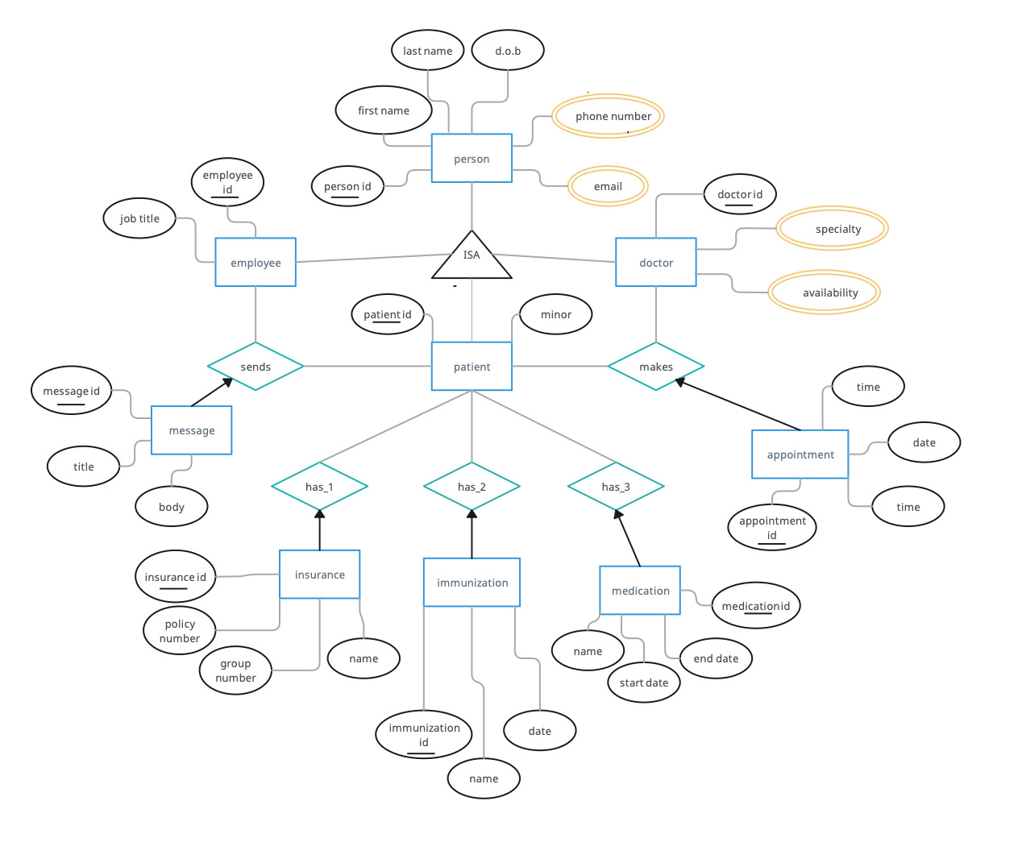

**Test Plan**

|  |  |  |
| --- | --- | --- |
| **Test** | **Expected Result** | **Fulfills test of query #** |
| Enter the following company record:  Name: Big Bob’s Ball Bearings, Bananas, Roller Skates & Floor Wax Inc  Address: 65 Tripp St  City: Niagara Falls  State: NY  Zip: 14301  Telephone: 7165553764  Industry: Retail  CompanyType: LLC | No error | 1 |
| Attempt to enter duplicate record | Error, an appointment already exists | 1 |
| Enter the Appointment record:  Location: Online  Date: 12:00 P.M.  Time: 04/05/2023  Patient Name: Adam Johnson  Doctor Name: Dr. Carson  Generates unique Appointment key | Error, time and date validation fails | 1 |
| Modify the doctor_id in an appointment:  appointment_id: 123423  doctor_id: 123412 | Success-  The doctor of an appointment is changed | 2 |
| Look up appointment_id:  412445 | Find records of an appointment | 3 |
| Look up patient_id:  234123 | Find records of Immunization, Medication, Insurance for a specific patient | 4 |
| Look up doctor_id:  342534 | Find records for a specific Doctor | 5 |
| Create a message record:  sender_id: 234234  receiver_id: 342343  Title: Concussion  Body: Symptoms include, headaches, sensitivity to noise and light | Success | 6 |
| Create a message record:  sender_id: 231232  receiver_id: NULL  Title:  Concussion  Body:  Symptoms include, headaches, sensitivity to noise and light | Error, no receiver_id was included | 6 |
| Delete an appointment  Enter appointment_id:  893425 | Success -  Deletes an appointment record from the appointment table | 7 |
| Delete an appointment  Enter appointment_id:  783312 | Error -  There is no appointment associated with the appointment_id | 7 |
| Add a patient_id to the immunization table:  Patient ID: 234132 | Success -  Adds a patient_id record under the immunization table | 8 |
| Add a patient_id to the insurance table  Patient ID: 234132 | Success -  Adds a patient_id record under the insurance table | 9 |
| Add a patient_id to the medication table  Patient ID: 234132 | Success -  Adds a patient_id record under the medication table | 10 |
| Enter the appointment record:   appointment_id: 134121 | Success-  Finds record and provides date, time and location for an appointment | 11 |